
Research Report: Cx Perceptions of Nearby Offerings
Q2 2023 | Cx Research | DRIs: Jessica ReedKhalil GrellKelly Peterson | Research Brief | GTM | Results

| Background:
The affordability marketing team relaunched Nearby, offering $0 delivery fee to 28 Nearby submarkets, leveraging owned channels (email, push, in-app merchandising) to resurrect our dormant and churned user base, while also driving more incremental orders from our active cohorts. Our high level goal of the experiment is to understand the incrementality of owned marketing using affordability messaging. We hope to use research to better understand the impact of marketing to a) drive awareness, b) build feature understanding, c) grow Cx satisfaction, and d) change perceptions of DoorDash as being an affordable option

This project aims to answer the following questions about consumers who have engaged with Nearby Marketing and a) converted or b) didn’t convert:
- Customer awareness: Do customers remember seeing Nearby marketing (either in-app or CRM)? Which assets do Cx remember? When did customers first come into contact with Nearby marketing? Do customers remember seeing the Nearby carousel?
- Feature understanding: Did our marketing message successfully drive customer understanding of the value prop/how the feature works? Was there any confusion or issues with comprehension of the feature?
- Customer satisfaction: How did Cx perceive the nearby value prop? Was the offering what Cx expected once they viewed the nearby carousel? During the process of checking out? What would make Nearby more enticing to Cx?
- Perception of low-fees: Did Nearby change customer perceptions of fees on DoorDash?

| Findings & Recommendations
 | FINDINGS |  | RECOMMENDATIONS
1 | CRM and in-app marketing are proving to drive awareness of ‘Nearby’, with 83% of Cx saying they remember seeing some iteration of $0 delivery fee marketing.  - 44% of Cx said they recalled email marketing in particular.  - Note: Awareness numbers may be inflated due to the potential confusion of ‘Nearby’ with additional $0 delivery fee options within the app | ⇢ | - For a full-scale launch, build out automated CRM flows that decrease in frequency over time  - Keep CRM touchpoints fresh with new creative assets and increased personalization (e.g., Mx-first comms based on order, saved, and abandoned cart behaviors).
2 | Marketing of ‘Nearby’ is seen as “clear” by 84% of Cx, with 51% of those Cx saying that it’s “very clear.”  For Cx who found the product unclear, the main cause was a lack of understanding of our fee structure (i.e. delivery fees versus service fees).  - “$0 delivery fees don't equal $0 fees at check out.” | ⇢ | - Conduct follow-up research with Cx around service fees to determine clear but still compelling ways to sell-in the offer  - Explore testing the impact of $0 total fees (service fees included) in future testing iterations (e.g., Flat Fee Meals)
3 | Price and selection are still the biggest issues for why Cx didn’t place an order, even with the existence of $0 delivery at select Nearby restaurants.  - 28.5% of Cx reported not being interested in any of the restaurants available to order from  - 27.6% of Cx reported that the fees were still too high  - 26% of Cx reported that the total was more than they wanted to spend  - 25.2% of Cx reported that the prices of items were too high  - Examples:  - “Price was the main reason. Still too high.”  - “Service fees are too high.”  - “Disappointed with the $0 delivery fee options” | ⇢ | - Leverage ‘Taste of DashPass’ to provide Cx with the broadest initial selection  - Upsell Cx to DashPass as the greatest way to save
4 | While Cx who converted believe we’re more affordable than those who did not, there’s still work to be done to shift consumer mindsets.  - 16% of All Cx (21% of converted Cx) strongly agree that DoorDash offers affordable food options.  - 21% of All Cx (32% of converted Cx) strongly agree it’s easy to find meals that fit their individual budget.  - 8% of All Cx (11% of converted Cx) strongly agree that overall, the fees on DoorDash are fair. | ⇢ | - Drive greater discounts and/or more personalized messaging to Cx who don’t convert from our initial offers  - Consider a pre- and post-marketing survey in an upcoming test with $0 DF + 10% off to continue monitoring a) consumer sentiment over time and b) Cx needs in order to convert

| Detailed Results

CUSTOMER AWARENESS:
CRM and in-app marketing are proving to drive awareness of ‘Nearby’, with 83% of Cx saying they remember seeing some iteration of $0 delivery fee marketing and 44% of Cx said they recalled email marketing in particular.
- [Note: Awareness numbers may be inflated due to the potential confusion of Nearby with additional $0 delivery fee options within the app.]

Marketing is driving awareness of our nearby offering with 92.3% of Cx reporting having seen that DoorDash was offering $0 delivery fees at nearby Rx. Nearby had the highest recall rate as compared to other products like grocery and reduced delivery time. The numbers below are reflective of Cx selecting choices that were predetermined by the research/marketing team.
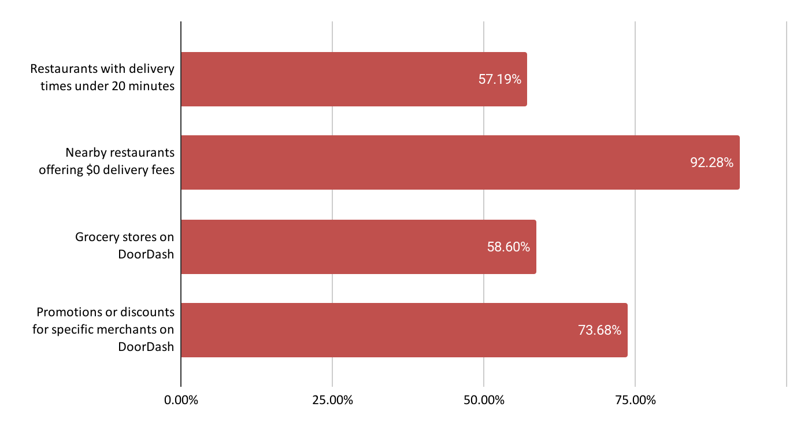

Base: Total Answering Cx (n=228)
Question: Q6: We would like to get an understanding of which features you’ve seen available on the DoorDash app. Of the options below, which features have you seen available on DoorDash?
83% of Cx saying they remember seeing some iteration of $0 delivery fee marketing. Email made the biggest impact on Cx with 44% of respondents indicating they recall receiving an email; 37% of Cx recall in-app marketing. Pushes made less of an impression overall with only 29% recall , however it is possible that Cx have those notifications turned off or that they think text/push are the same channel.
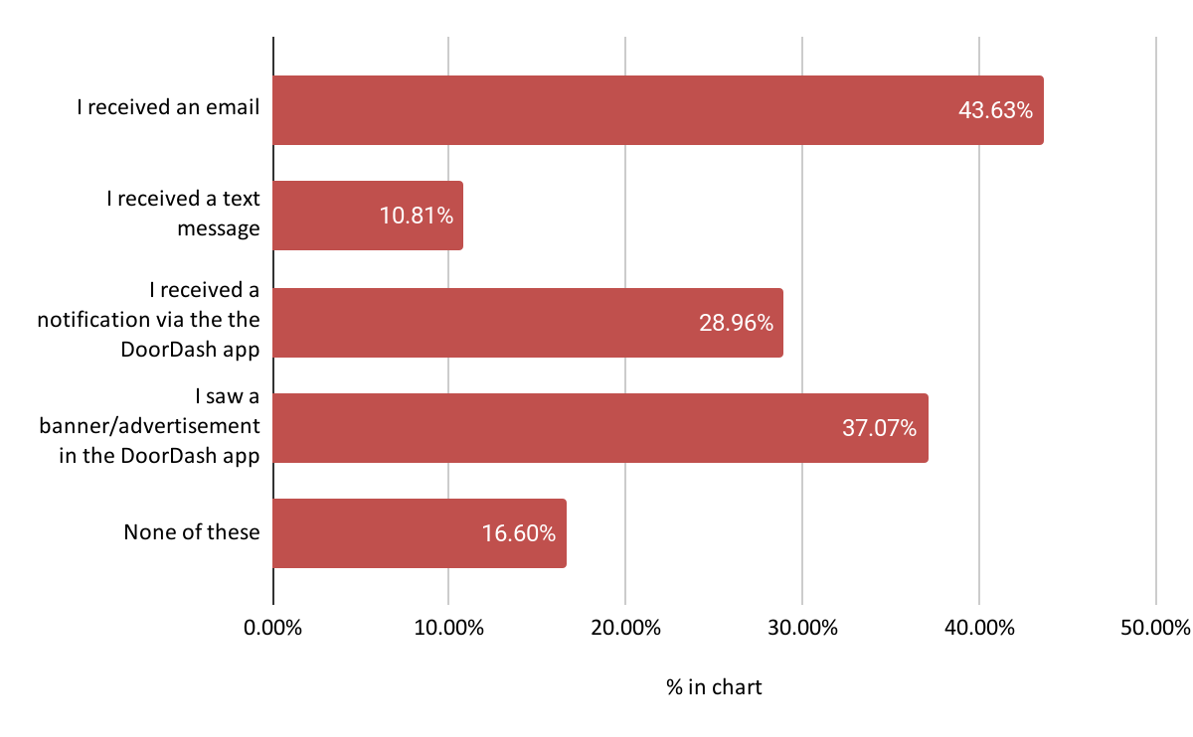
Base: Total Answering Cx (n=228)
Question: Q9: DoorDash recently added a feature where users are given a selection of Nearby restaurants eligible for $0 delivery fee. Do you remember seeing any emails, text messages, or in-app advertising about Nearby restaurants offering $0 delivery fee? Select all that apply

Cx recollection of the product favors recency, with 58% of Cx having seen the product in our most recent relaunch. 19% of Cx remember seeing the product more than a month ago and about 23% of Cx were unsure.

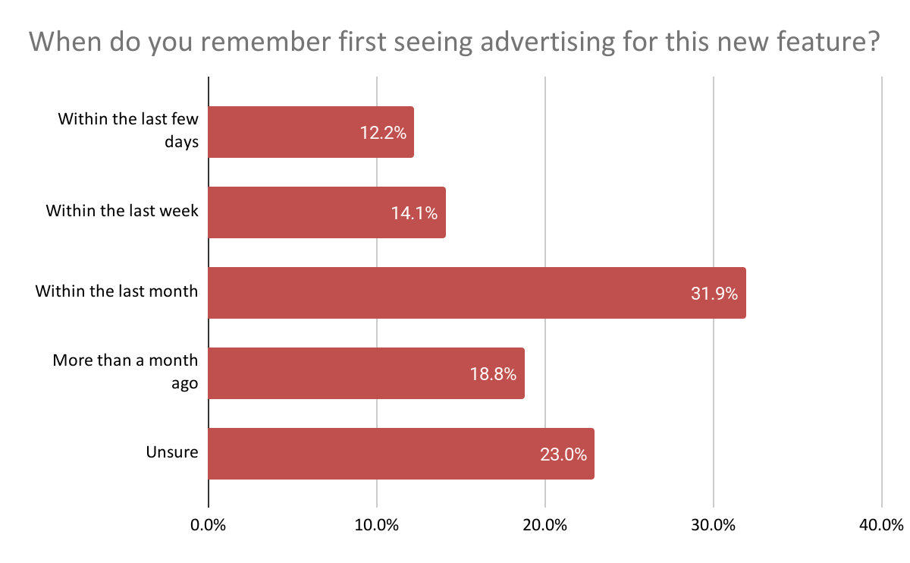

Recommendation:
- For a full-scale launch, build out automated CRM flows that decrease in frequency over time
- Keep CRM touchpoints fresh with new creative assets and increased personalization (e.g., Mx-first comms based on order, saved, and abandoned cart behaviors).

FEATURE UNDERSTANDING
Marketing of ‘Nearby’ is seen as “clear” by 84% of Cx, with 51% of those Cx saying that it’s “very clear.” For Cx who found the product unclear, the main cause was a lack of understanding of our fee structure (i.e. delivery fees versus service fees).

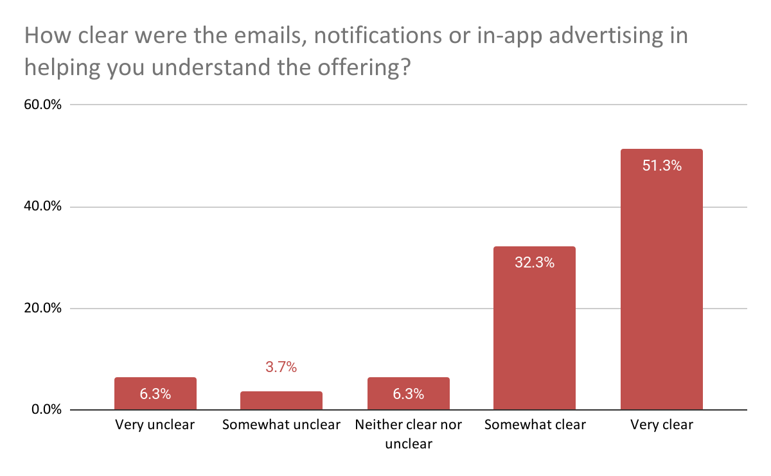
Base: Cx Who Recalled Marketing (n=169)
Question: Q15: How clear were the emails, notifications or in-app advertising in helping you understand the offering?

Of the Cx who said marketing was unclear, they mentioned they expected to receive $0 total fees overall.

“$0 delivery fees doesn’t equal $0 fees at check out. I’m always shocked how much all your fees add on to the cost of my meal. My husband & I make $500k combined & I still can’t justify using your service often because it’s so much more expensive than getting take out.”

Recommendation:
- Conduct follow-up research around service fees to determine clear but still compelling ways to sell-in the offer
- Explore testing the impact of $0 total fees (service fees included) in future testing iterations (e.g., Flat Fee Meals)

CUSTOMER SATISFACTION
Price and selection are still the biggest reasons why Cx didn’t place an order, even with the existence of $0 delivery at select Nearby restaurants.
- 28.5% of Cx reported not being interested in any of the restaurants available to order from
- 27.6% of Cx reported that the fees were still too high
- 26% of Cx reported that the total was more than they wanted to spend
- 25.2% of Cx reported that the prices of items were too high

It is possible that Cx were answering generally why they didn’t convert, and not why they didn’t convert through nearby, especially given the possible confusion between all $0 DF and nearby $0 DF cited throughout the study.
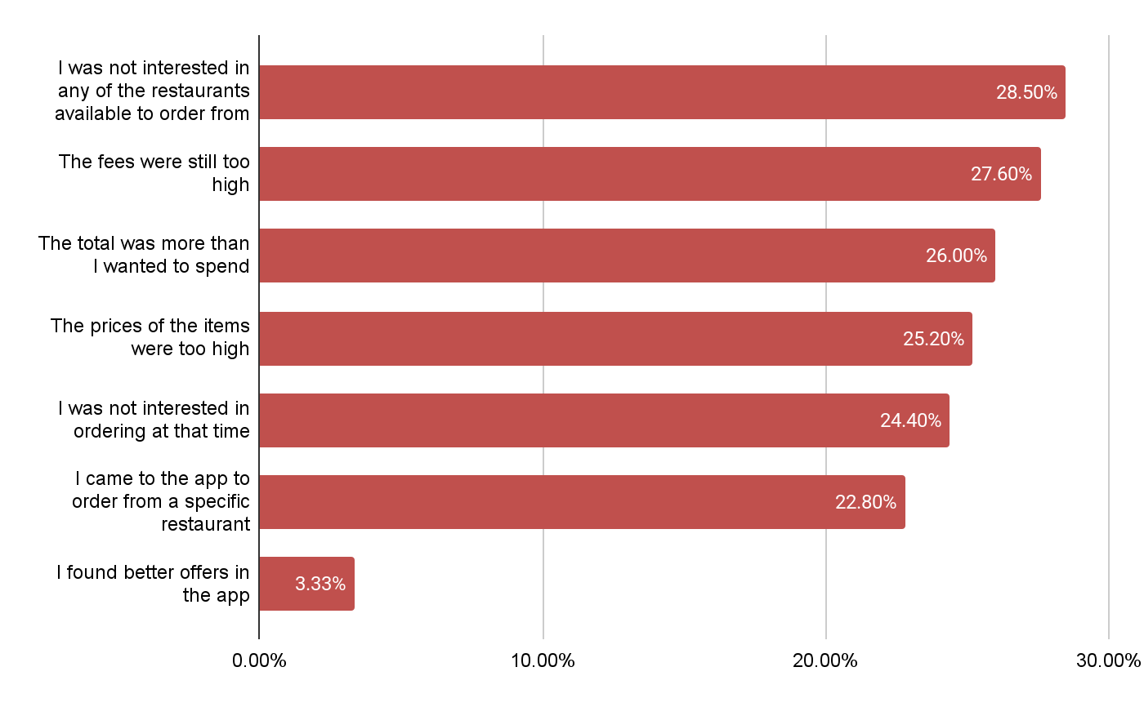

Base: Total Answering Cx (n=228)
Question: Q21: Which of the following best describes why you did not place an order from a Nearby restaurant with a $0 delivery fee. Select all that apply. - Selected Choice.
Cx consistently cited price and selection for why they ultimately did not place an order:
- “Price was the main reason. Still too high.”
- “Fees have increased significantly”
- “Service fees are too high.”
- “Price and tip of dasher”
- “Wasn’t hungry for specific restaurant”
- “Disappointed with the $0 delivery fees option”
- “Too expensive even with a $0 fee. And for that price, food comes lukewarm. Would rather just get food myself.”
- “If they could have like a flat fee for using doordash versus charging more for all the food items and having a fee and a delivery fee it’s ridiculous”
- “Even with low delivery rate is still expensive”
- “Weren’t that many [nearby rx]”
- “Expensive”

For the 37% of Cx who reported converting, internal data suggests that the actual number could be much lower (2%). This disparity could be attributed to Cx ordering from Nearby during an early iteration of the experiment or from potential confusion of Nearby with additional $0 delivery fee options within the app.
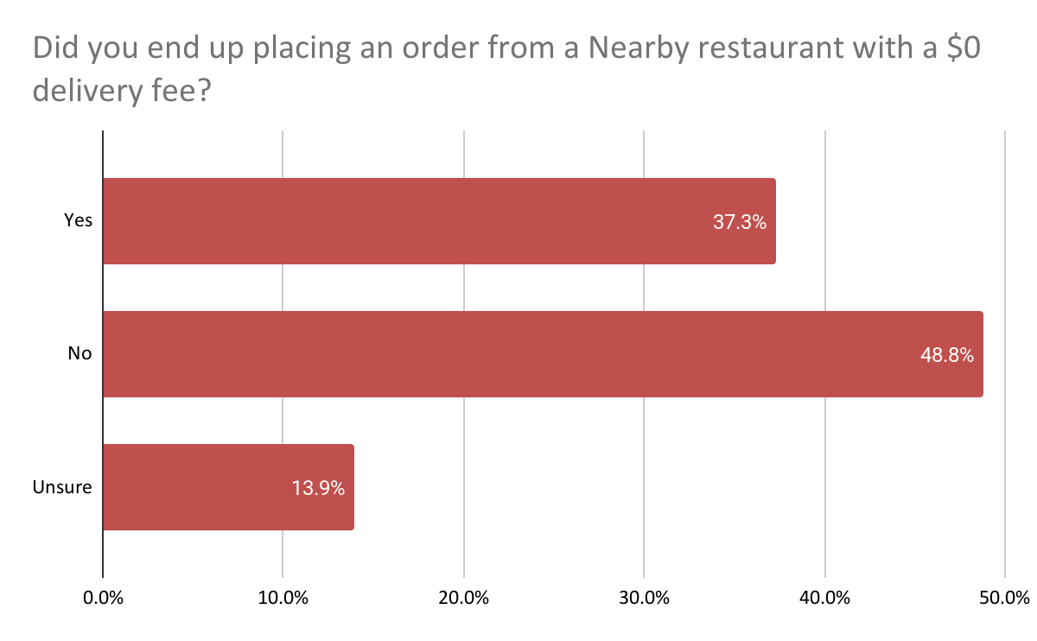
Base: Total Answering Cx (n=228)
Question: Q20: Did you end up placing an order from a Nearby restaurant with a $0 delivery fee?

Recommendation:
- Leverage ‘Taste of DashPass’ to provide Cx with the broadest initial selection
- Upsell Cx to DashPass as the greatest way to save

PERCEPTION OF LOW FEES
While Cx who converted believe we’re more affordable than those who did not, there’s still work to be done to shift consumer mindsets.
- 16% of All Cx (21% of converted Cx) strongly agree that DoorDash offers affordable food options.
- 21% of All Cx (32% of converted Cx) strongly agree it’s easy to find meals that fit their individual budget.
- 8% of All Cx (11% of converted Cx) strongly agree that overall, the fees on DoorDash are fair.

50% of all Cx agree that DoorDash offers affordable food options, with 16.2% strongly agreeing. While this is positive, half of Cx are still neutral or disagree, with 7.7% strongly disagreeing.

All Respondents | Cx Who Reported Ordering
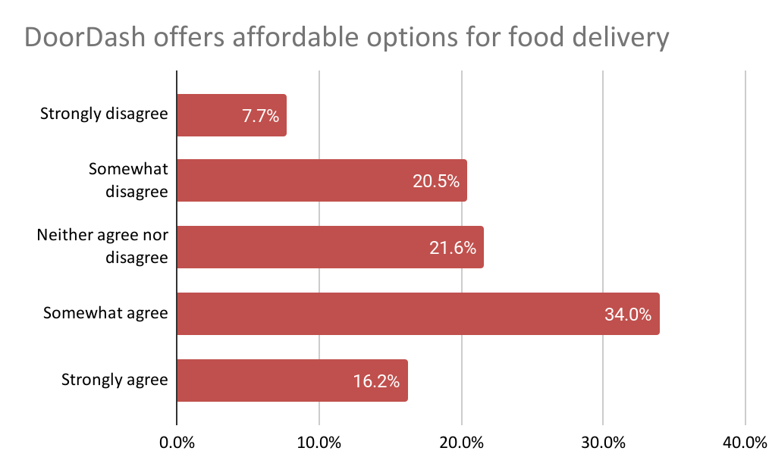 | 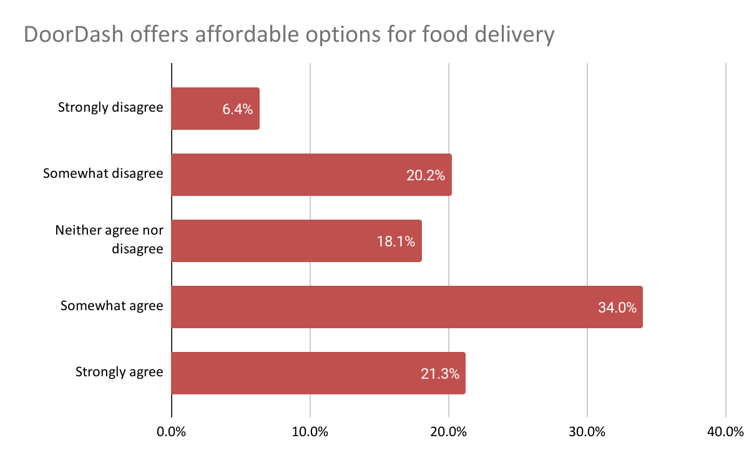
Base: Total Answering Cx (n=228)
Question: Q8: Now, we would like to understand your broad perceptions of DoorDash. Please state how much you agree or disagree with the following statements: 1) DoorDash offers affordable options for food delivery, 2) It is easy to find meals I enjoy for my individual budget, 3) Overall the fees on DoorDash are fair, and 4) Overall the fees on DoorDash have increased over time.
49.8% of all Cx believe it’s easy to find meals that fit their individual budget. Nearly one in four Cx are neutral, a slightly better stat than above, indicating more room for movement than on “DoorDash offers affordable options for food delivery.”

All Respondents | Cx Who Reported Ordering
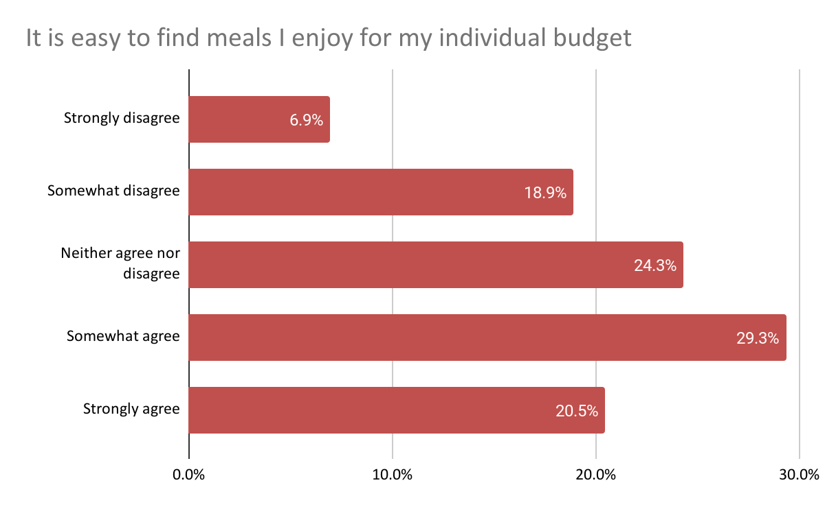 | 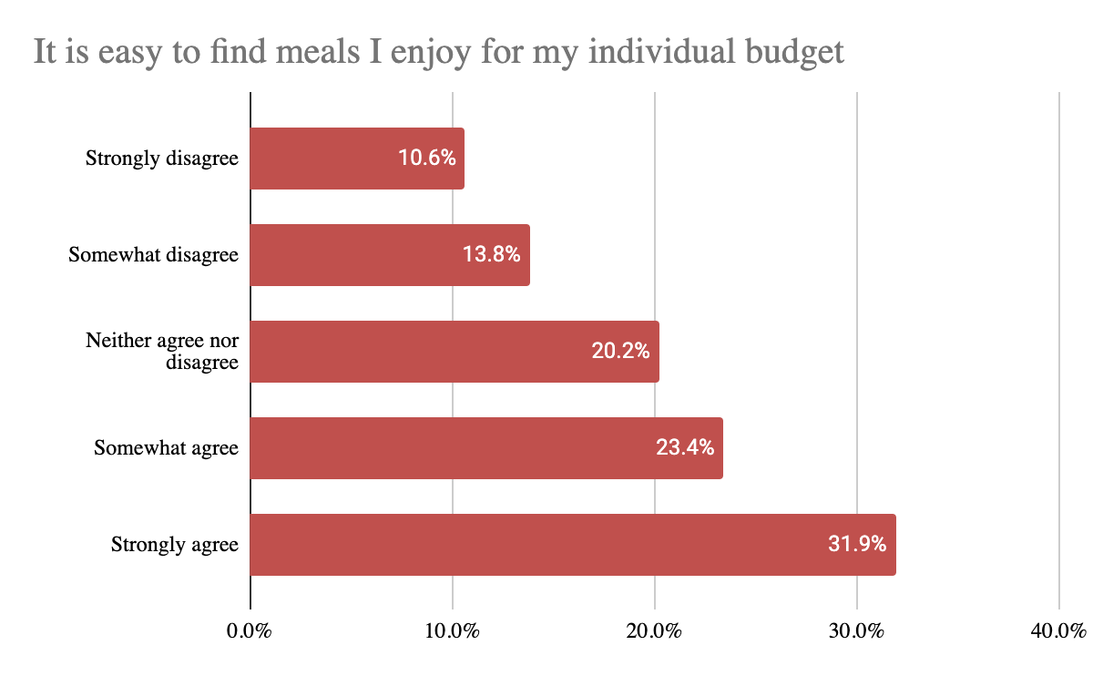
Base: Total Answering Cx (n=228)
Question: Q8: Now, we would like to understand your broad perceptions of DoorDash. Please state how much you agree or disagree with the following statements: 1) DoorDash offers affordable options for food delivery, 2) It is easy to find meals I enjoy for my individual budget, 3) Overall the fees on DoorDash are fair, and 4) Overall the fees on DoorDash have increased over time.
For Cx who stated that they did order from nearby Mx, reviews were slightly better with 55% in each category agreeing they can find affordable options or options that fit their individual budget on DoorDash. More importantly, they felt more strongly i.e. voted “strongly agree” more often than Cx who did not order nearby.

Only one in three surveyed Cx believe that the fees on DoorDash are fair, with 42% disagreeing and another 23.9% remaining neutral. For Cx who did order, the breakdowns are the same except that the distribution between somewhat agree and strongly agree are slightly varied.

All Respondents | Cx Who Reported Ordering
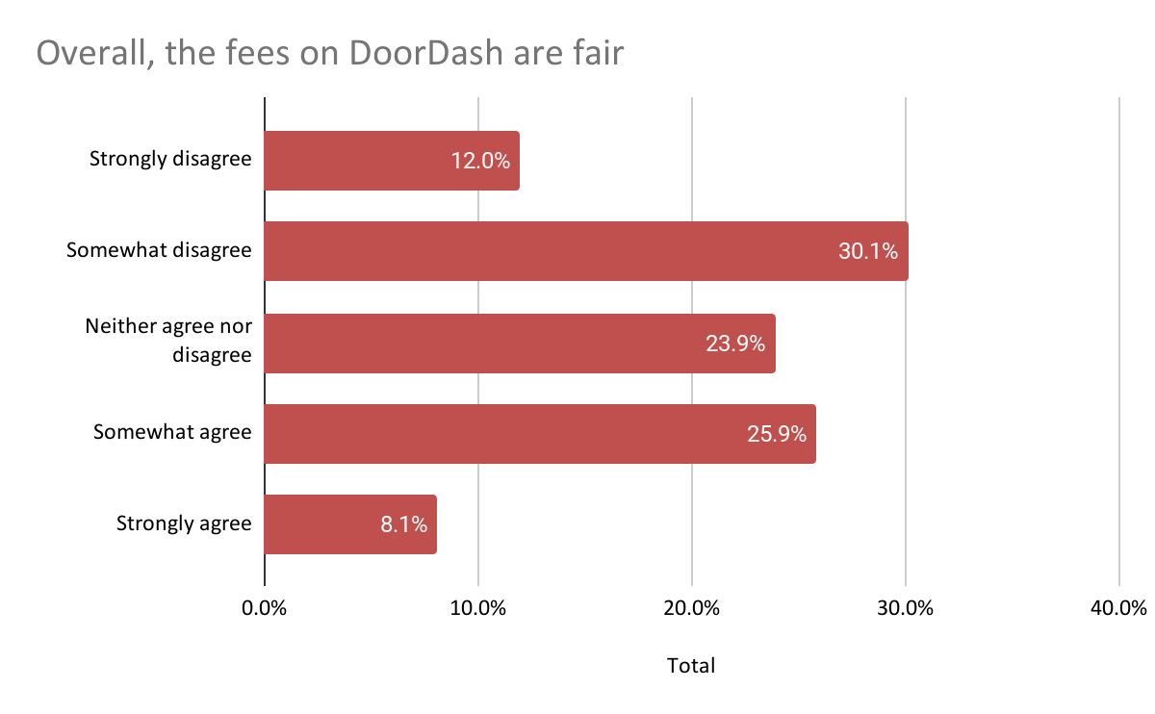 | 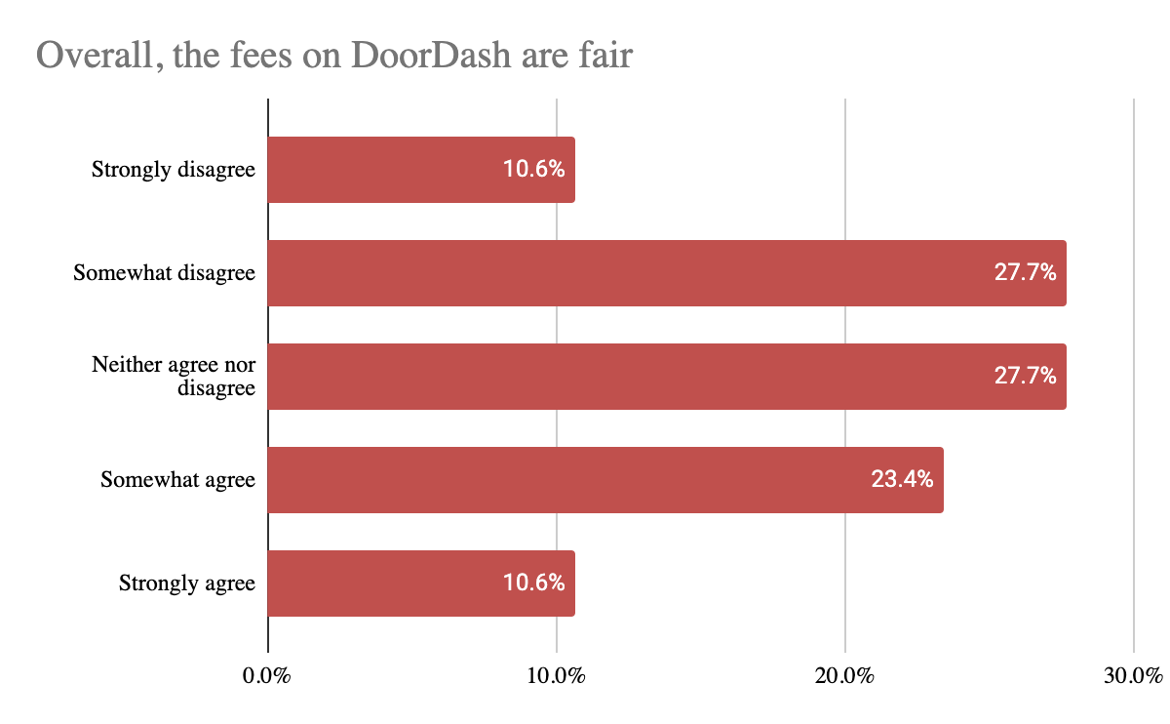
Base: Total Answering Cx (n=228)
Question: Q8: Now, we would like to understand your broad perceptions of DoorDash. Please state how much you agree or disagree with the following statements: 1) DoorDash offers affordable options for food delivery, 2) It is easy to find meals I enjoy for my individual budget, 3) Overall the fees on DoorDash are fair, and 4) Overall the fees on DoorDash have increased over time.

Recommendation:
- Drive greater discounts and/or more personalized messaging to Cx who don’t convert from our initial offers
- Consider a pre- and post-marketing survey in an upcoming test with $0 DF + 10% off to continue monitoring a) consumer sentiment over time and b) Cx need in order to convert

Appendix

Research Approach & Sample:
Research Approach: N=361 Classic Cx answered the survey, and N=228 Classic Cx completed the entire 10-minute survey from 4/7-4/23. These Cx were particularly targeted by the fact that they are in SMs currently receiving nearby v3 “$0 delivery fees at nearby restaurants” marketing, and were best suited to help our team understand how Cx are interacting with nearby marketing, the value prop, and their overall perception of fees on DoorDash.

Aided v. Unaided Recall:
Base: Total Answering Cx (n=228)
Question: Q9: DoorDash recently added a feature where users are given a selection of Nearby restaurants eligible for $0 delivery fee. Do you remember seeing any emails, text messages, or in-app advertising about Nearby restaurants offering $0 delivery fee? Select all that apply

Based on internal data, 118 of surveyed respondents did open a nearby email from us during this time and 44% report having done so, matching the overall survey data. It is possible that for the 99 that reported opening, they opened during previous nearby iterations. Aided recall for those who had opened the emails increased to 70% when we provided images.

Cx Satisfaction:
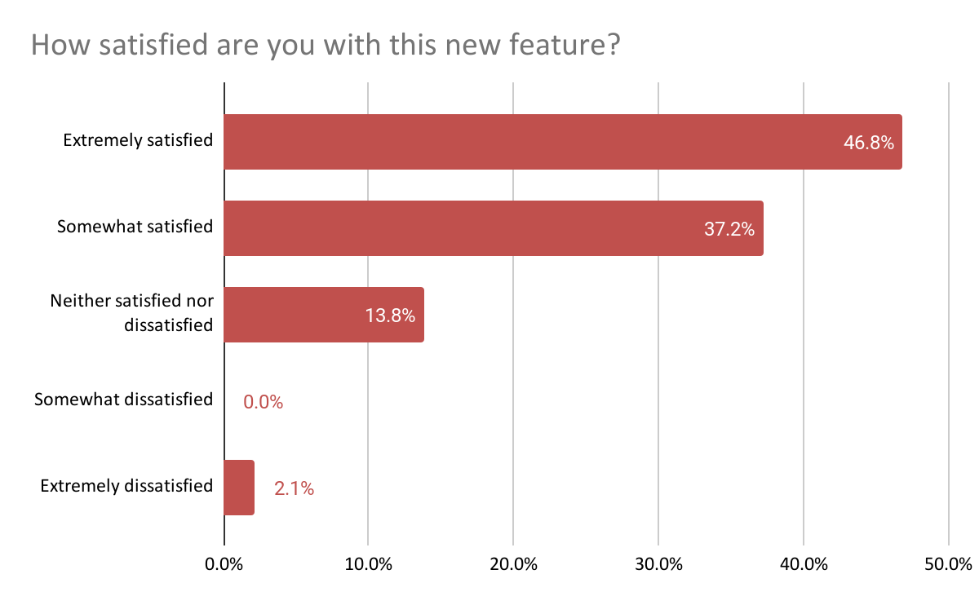
Base: Cx Who Ordered (n=85)
Question: Q23: Generally speaking, how satisfied are you with this new feature (i.e. seeing Nearby restaurant options where you can get $0 delivery fees on every order)?

